Mitochondria Tracker Instructions (Version 2)
Philip Chou
Change Log
Step 1: Processing the image sequence in Image J
(Optional) Install the Mitochondria Preprocess Macro into ImageJ. To install, go to Plugins>Marcos>Install and open the file “Mitochondria_Preprocess.txt”. The image should appear on your ImageJ toolbar if it was installed correctly.
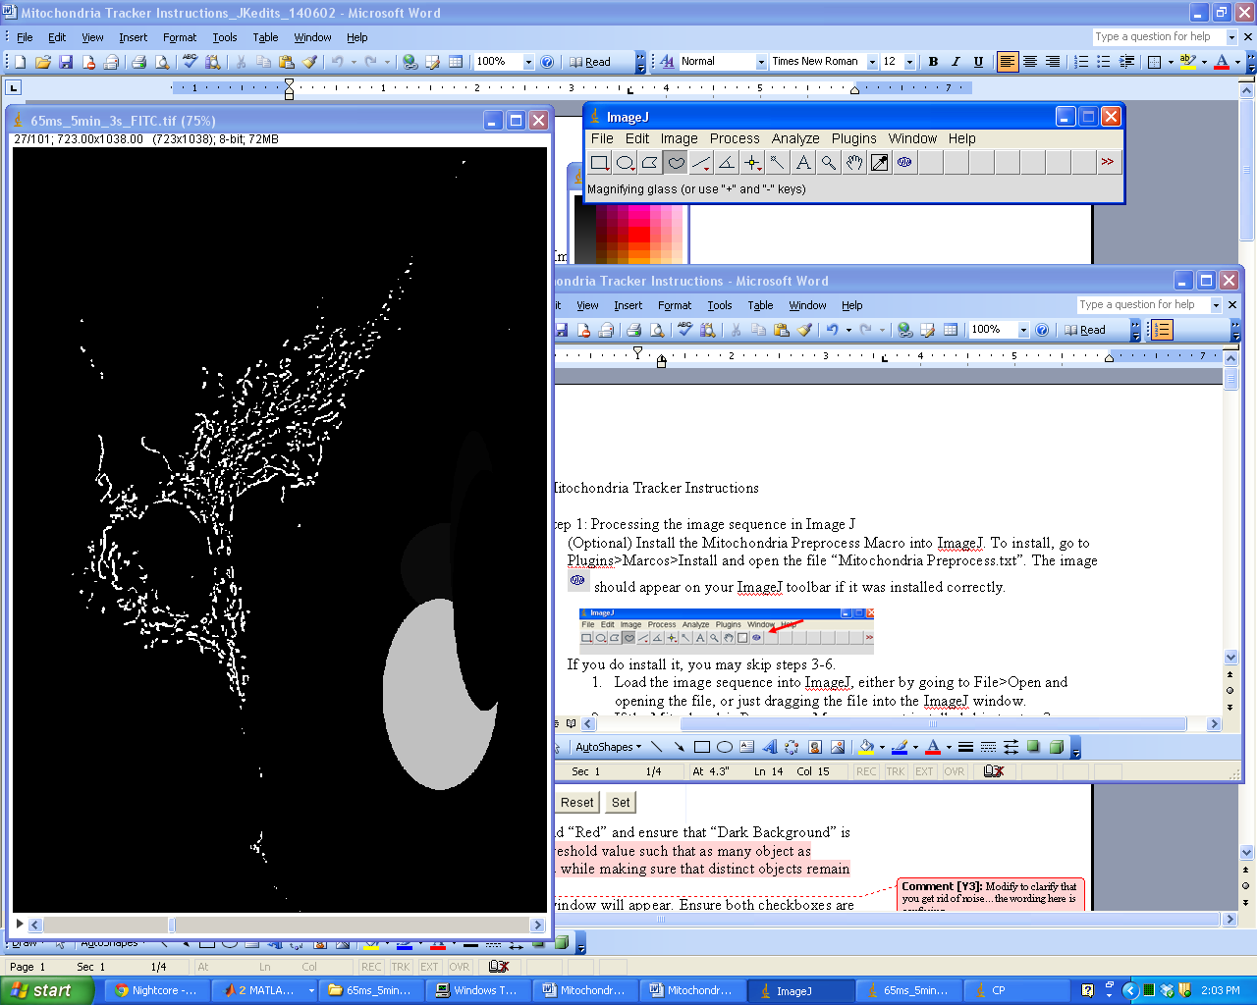
If you do install the macro, ensure that your background and foreground colors in the color picker are both black. Do this by double clicking on the icon or going to Image>Color>Color Picker and then selecting black for both the foreground and background.
If you DO install it, you may skip steps 3-6.
- Load the image sequence into ImageJ, either by going to File>Open and opening the file, or dragging the file into the ImageJ window.
- If the Mitochondria Preprocess Macro was NOT installed, skip to step 3.
  - Otherwise, select and click in the picture window once. A prompt will appear that says “Select cell to examine then press OK.” The tool will automatically switch to the “freeform tool”. Using the mouse, draw around only the desired cell and then press “OK” in the prompt window.
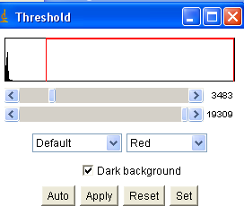
  - ImageJ will automatically crop and process the picture and blackout all that is not the desired cell. At the end, a threshold window will appear. Be sure the two drop down menus say “Default” and “Red” and ensure that “Dark Background” is checked. Adjust the threshold value such that all the objects are visible and noise in the picture is at a minimum.

  - Press “Apply”, a new window will appear. Ensure both checkboxes are checked before pressing “OK”
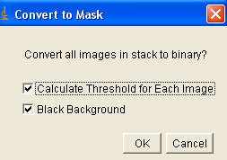
  - After ImageJ is finished, go to step 7.
- If Mitochondria Preprocess was not installed, use the freeform selections tool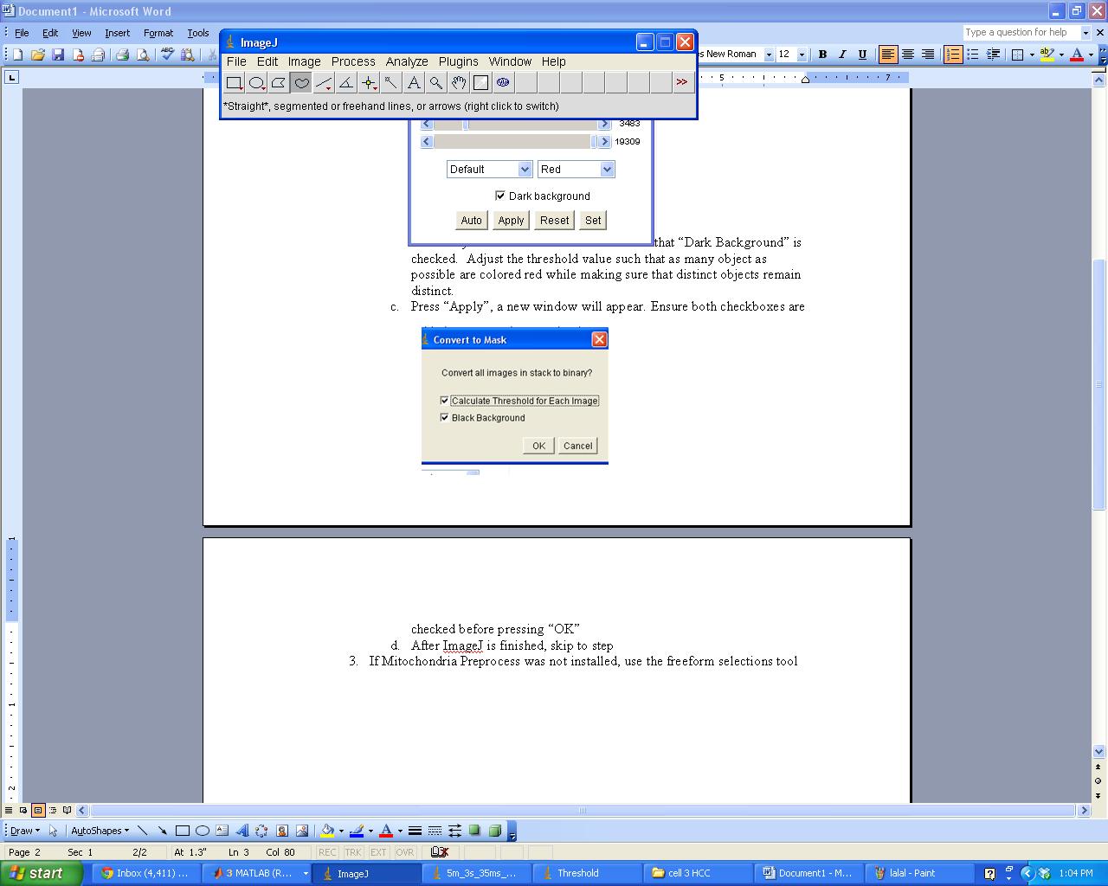 to draw around the desired cell. Crop the image by clicking Image>Crop. Use the freeform tool to select any surround undesired objects and go to Edit>Fill.
- After the desired cell is isolated in the image, use the convolution function to highlight the sharply contrasting regions. This is found in Process>Filters>Convolve…. Press “OK” in the resulting window.
- Next use a Fast Fourier Transform (FFT) Bandpass Filter on the image. 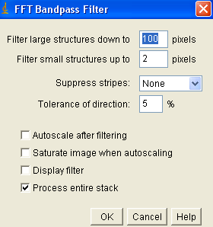
Process>FFT>Bandpass Filter…. Ensure that all the options (including the checkboxes) match those in the figure above before pressing “OK”

- Next go to Image>Adjust>Threshold and follow instructions 2b-2c.
- Finally go to File>Save As>Image Sequence…. Ensure that all options except for “Name” are the same as the figure below. Name the sequence an identifying name. Remember the name of the sequence for later processing, and press “OK”. Save the sequence. The files will be of the format: name0000.tif
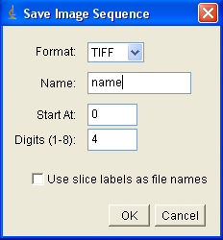

Step 2: Tracking the mitochondria in Matlab
- Download the files “interface.m”, “interface.fig”, and “mitochondria.m” into your current work folder in Matlab.
- Open “interface.m” in Matlab and run the file.
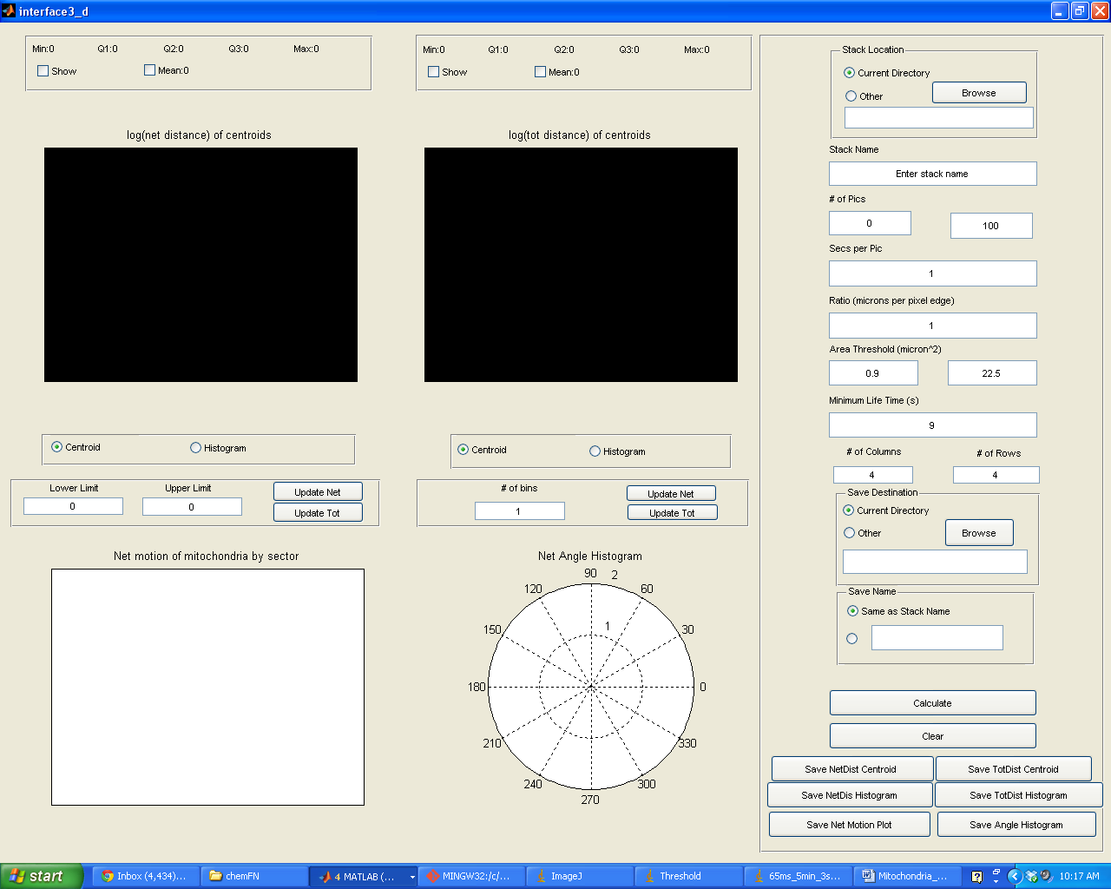

- Fill out the information in the right column.
  - First is the folder that the stack of pictures is in. If the pictures are saved in the same folder as “interface.m”, choose “Current Directory”. If not, click “Browse” to find the folder that contains the pictures.
  - For stack name, it is the “NAME” portion of the NAME0000.tif files. (The entire name before the last 4 digits)
  - Picture Numbers denotes the pictures over which you want to analyze. The numbers refer to the last four digits of the stack files.
  - The picture increments option allows you to evaluate intervals of pictures, as opposed to every one. There are options for every 1, 2, 3, 4 and 5.
  - Secs per Pic is the amount of time between capturing each picture.
  - Ratio is the ratio of micrometers per pixel edge
  - Area Threshold is the lower and upper area limits that the function will use to decide whether or not an object is a mitochondria. Units are in μm².
  - Minimum Lifetime is the minimum amount of time that an object must exist to be considered by the program. Units are in seconds.
  - The number of Columns and number of rows options will determine the number of divisions in the quiver plot, the plot that will show net motion per sector.
  - Save Destination is the folder that the data will be saved into. It can either be in the same folder that “interface.m” resides in or any other path can be chosen.
  - Save name is the name that Matlab will save the data under. It can either be the same as the current stack name, or a custom name. NOTE: Ensure Save name is alphanumeric or underscores (‘_’) and starts with a letter. If there are any non alphanumeric characters, they will be replaced with an underscore. If they start the save name, they will be deleted.
- Press Calculate
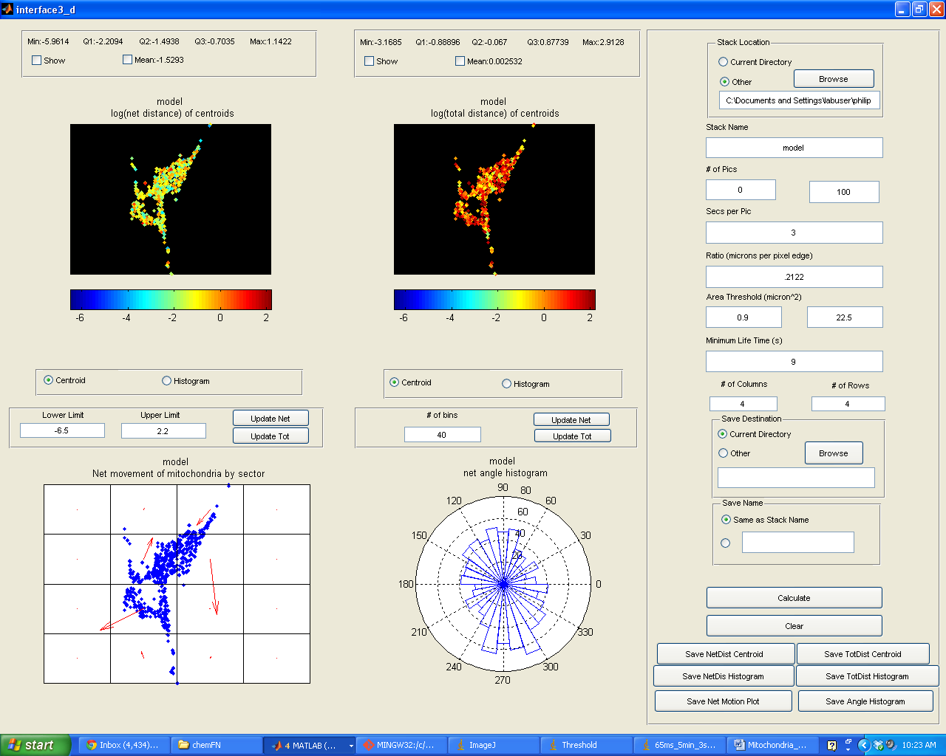
After pressing calculate, the program will save the total distance, the net distance and the net angles traveled by the mitochondria. In addition it will save the parameters used for the calculations. All of this will be saved in a file called “[name]Data.mat”
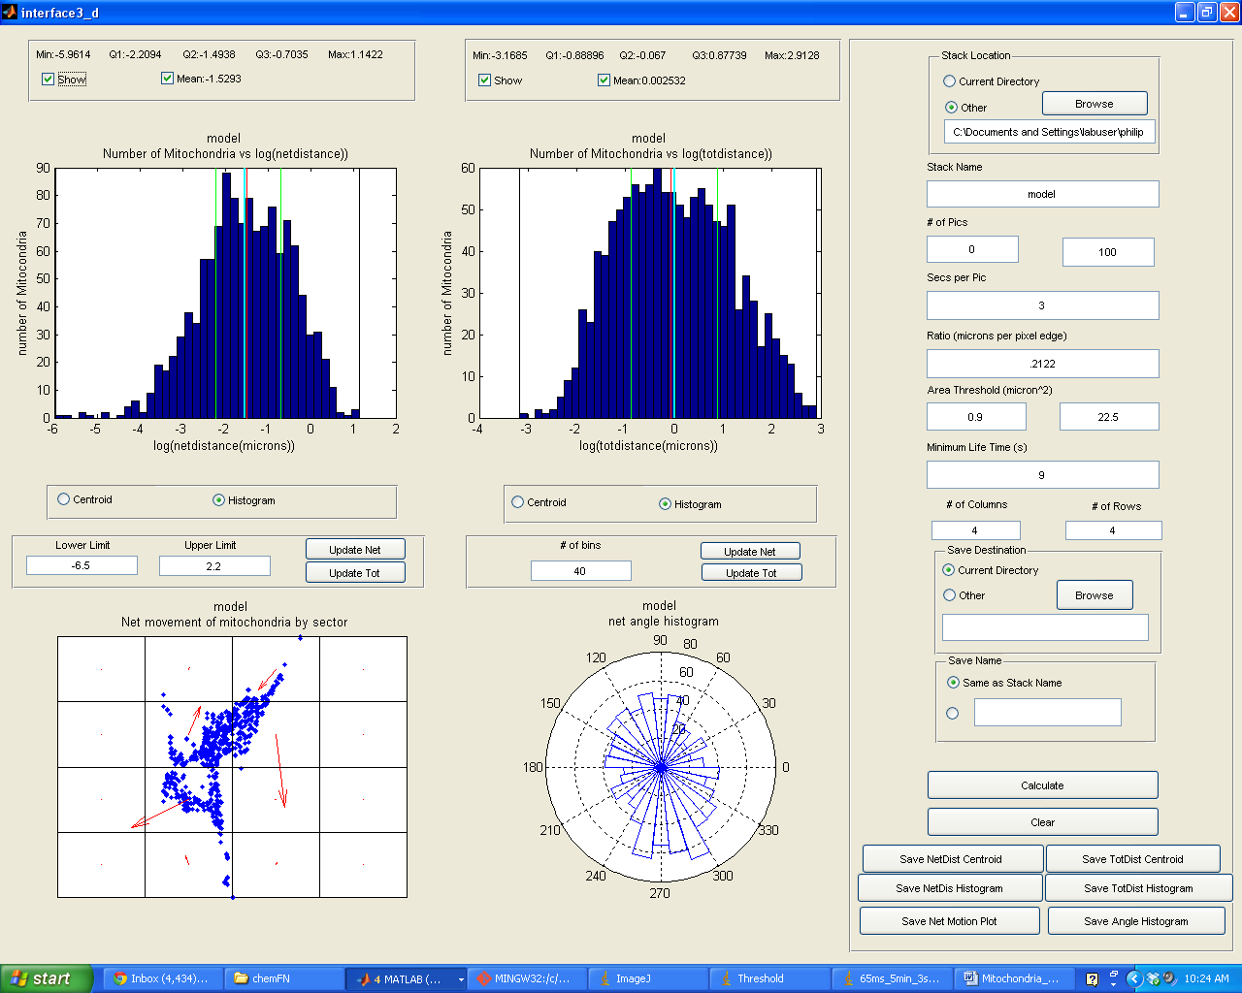
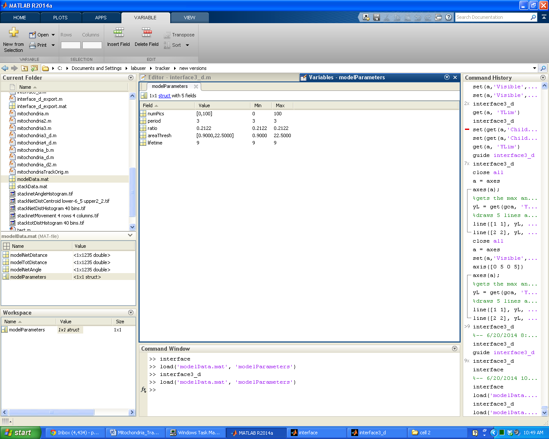

  - The plots on the top are plots of the natural logarithm of the net distances and total distances traveled by the mitochondria. To measure net distance, the positions of the centroid of any specific object are recorded from the first and last frames that the specific object existed in the image sequence. The difference in position is measured and this is the net distance traveled. The total difference is measured by summing the distance traveled between every image. The dots are color coded by how far they traveled, the redder the dots, the further they traveled, and the bluer the dots, the less they traveled. The dots are placed at the centroid position of the final frame for all objects.
  - These plots can be toggled to show the histogram plots by pressing the histogram under each plot. The histogram will show the distribution of how many mitochondria traveled a specific distance.
  - The plot in the bottom left plots the net distance a sector of the cell traveled. It sums up the net distance and direction of every mitochondrion in that area and then plots the arrow.
  - The plot in the bottom right is a rose plot which is a histogram of the net angles that the mitochondria traveled.
- Misc Instructions:
  - “Clear” clears the plots, and all the textboxes
  - “Save (Net/Tot) Centroid Plot” saves the plot of the centroids of the mitochondria to the save destination. It will save the plot with a name of format “[name](Net/Tot)Centroid lower[lower limit] upper [upper limit].tif”
  - “Save (Net/Tot)Histogram” saves the histogram plot to the save destination. It will save the plot with a name of format “[name] (Net/Tot)Histogram [# of bins] bins.tif”
  - “Save Net Motion Plot” saves the quiver plot to the save destination. It will save the plot with a name of format “[name]netMovement [# of rows] rows [#of columns]columns.tif”
  - “Save Angle Histogram” saves the rose plot to the save destination. It will save the plot with a name of format “[name]netAngleHistogram.tif”
  - Changing “Lower Limit” and “Upper Limit” and clicking “Update (Net/Tot)” will update the color bar of the (Net/Tot) centroid plot
  - Changing “# of bins” and clicking “Update (Net/Tot)” will change the number of columns there are in the (Net/Tot) histogram plot.
  - Toggling “Show” underneath Min, Q1, Q2, Q3, Max will toggle the quartile lines on the histogram. Black indicates Min and Max, Green indicates Q1 and Q3 and Red indicates the median
  - Toggling the “Mean” checkbox will toggle a cyan line which indicates the mean.
  - Important Note: If the image stack is named with non alphanumeric characters (white space, any other symbol, etc) and current save name is selected, the program will automatically replace all non alphanumeric symbols with an underscore and delete all preceding underscores.
For example: !a-b0000.tif -> a_b0000.tif

